STM32 on Keil IDE Setup Guide Line

# Chapter 1: Create New Project

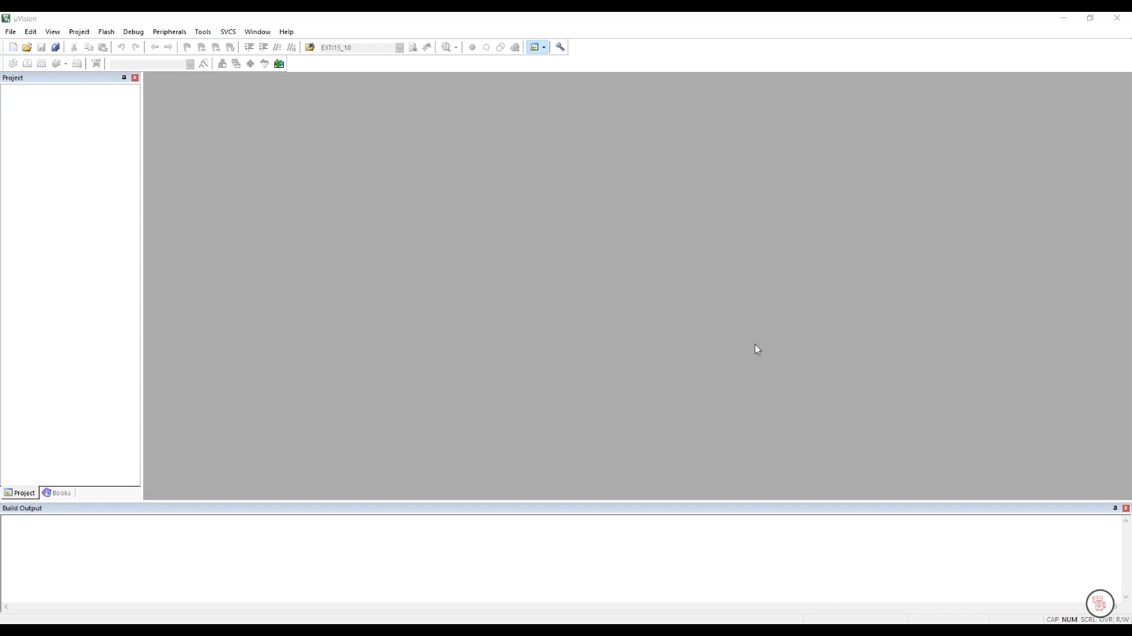Step 1: Open the IDE

Step 2: Go to the Project tab and Hit the New uVision Project…

